**수치연산**

1. **Select *from sample34;**
2. **Select *, price * quantity from sample34;**
3. **Select *, price * quantity as “금액” from sample34;**

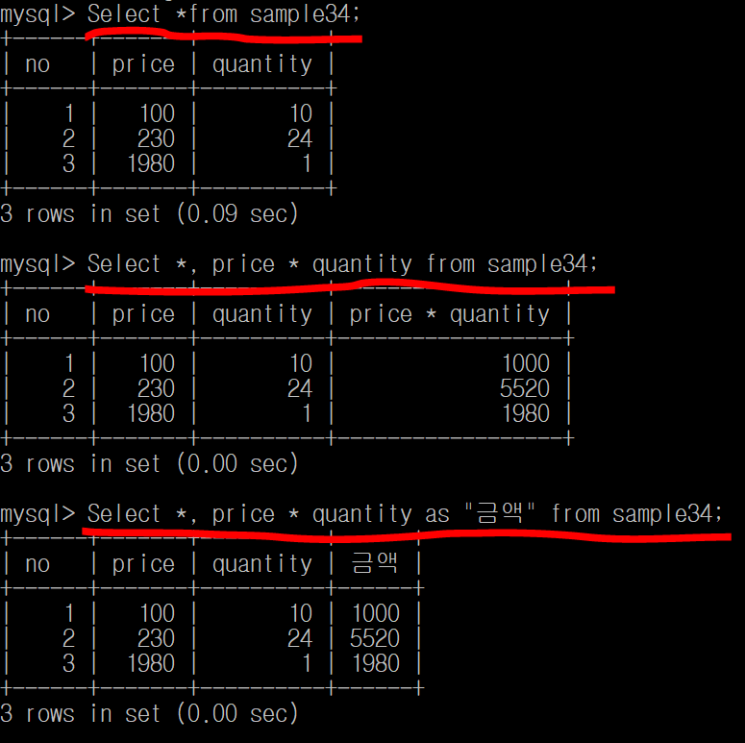

**Price * quantity를 곱한 결과를 출력해라**

**Price * quantity 결과를 “금액” 이름으로 출력해라**

1. **Select *from sample34;**
2. **Select *, price * quantity as “금액” From sample34;**
3. **Select *, price * quantity as “금액” From sample34**

**Where price * quantity >= 2000;**

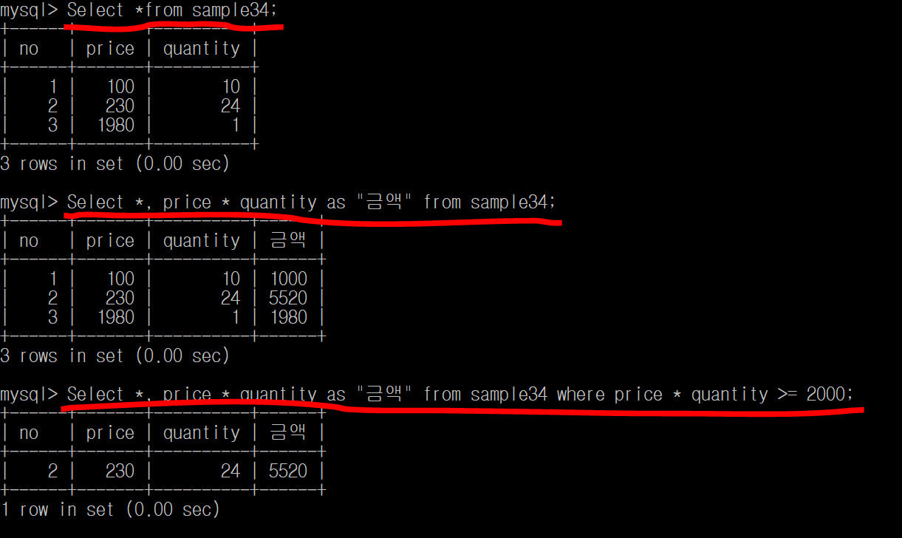

**Price * quantity 결과를 “금액” 이름으로 출력해라**

**Price * quantity 결과 중에 2000보다 큰 것만 출력해라**

1. **Select *from sample34;**
2. **Select *, price * quantity as “금액” From sample34;**
3. **Select *, price * quantity as “금액” From sample34**

**Order by price * quantity desc;**

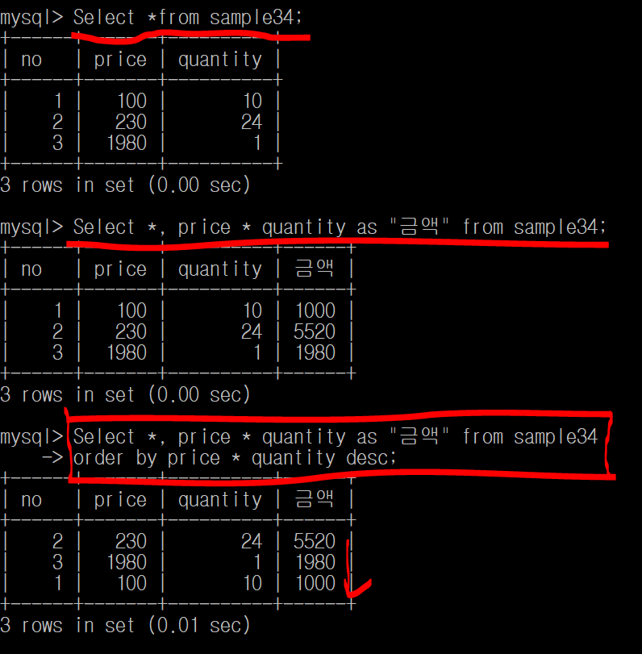

**Price * quantity 결과를 “금액” 이름으로 출력해라**

**Price * quantity 결과를 “금액” 이름으로 내림차순 출력**

1. **Select *from sample341;**
2. **Select *, round(amount) from sample341;**
3. **Select *, round(amount, 1) from sample341;**
4. **Select *, round(amount, -2) from sample341;**

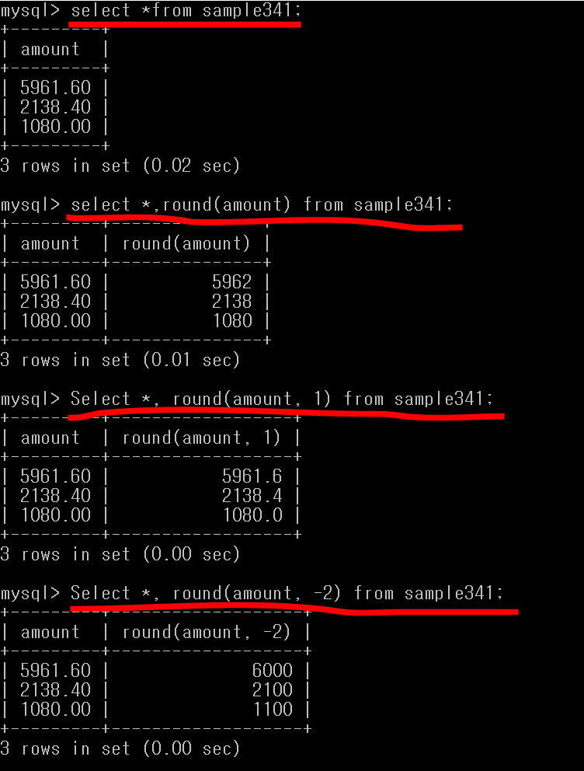

**소수점 0번째자리에서 반올림해라 (1234.56)**

**소수점 1번째자리에서 반올림해라 (1234.56)**

**소수점 -2번째자리에서 반올림해라 (1234.56)**